PSA Hermes Transition

Application Overview Document

[Note: The following template is provided for use with all ADC systems development projects. Text enclosed in square brackets and displayed in blue italics (style=InfoBlue) is included to provide guidance to the author and should be deleted before publishing the document. A paragraph entered following this style will automatically be set to normal (style=Body Text).]

[To customize automatic fields (which display a gray background when selected), select File>Properties and replace the Title, Subject and Company fields with the appropriate information for this document. After closing the dialog, automatic fields may be updated throughout the document by selecting Edit>Select All (or Ctrl-A) and pressing F9, or simply click on the field and press F9. This must be done separately for Headers and Footers. Alt-F9 will toggle between displaying the field names and the field contents. See Word help for more information on working with fields.

The following data is stored in the corresponding fields:

Client Name: Custom.Client

Project Name: Custom.Project

Author: Summary.Author

Approver Custom.Checked by

Version Custom.Disposition]

**Document Control**

Revision History

|  |  |  |  |
| --- | --- | --- | --- |
| **Date** | **Version** | **Author** | **Description** |
| 29/06/2016 | 1 | Gaurav Dubey | Creation of document |
|  |  |  |  |
|  |  |  |  |
|  |  |  |  |

Distribution

|  |  |  |  |
| --- | --- | --- | --- |
| **Name** | **Title** | **Document Version** | **Date** |
|  |  |  |  |
|  |  |  |  |
|  |  |  |  |
|  |  |  |  |
|  |  |  |  |

Approval Signatures

|  |  |  |  |  |
| --- | --- | --- | --- | --- |
| **Name** | **Title** | **Document Version** | **Signature** | **Date** |
|  |  |  |  |  |
|  |  |  |  |  |
|  |  |  |  |  |
|  |  |  |  |  |

**Table of Contents**

OBJECTIVES 5

1. Business 6

1.1. Business Overview 6

1.2. Business Processes 6

1.3. Business Interrelationships 6

1.4. Business Criticality 6

2. Functional 6

2.1. Functional Overview 6

2.2. Functional Details 7

2.3. Data Flow 7

3. TECHNOLOGY RELATED 7

3.1. Technical Overview 7

3.2. Application Architecture 8

3.3. Application Platform 9

3.4. Source Code Control 9

3.5. Production, UAT and Development Locations 9

3.6. Hardware and Software Pre-requisites 9

3.7. Interfaces to other systems 9

3.8. Documentation 10

3.9. Network Specific Issues 10

3.10. Third Party Tools 10

4. Technical Environment 10

4.1. Server Names 10

4.2. Web Locations 10

4.3. Web URLs 10

4.4. On-Line Region 10

4.5. Libraries 10

4.6. Software Requirements 10

4.7. Server/Application access requirements 10

4.8. Login IDs on Production and Development 10

4.9. Test data and Test environment 10

4.10. Change Control Procedure 10

4.11. Forms 10

4.12. Reports 10

4.13. Tools 11

4.14. Methodologies 11

4.15. Complexity 11

4.16. Unusual coding practice 11

4.17. Commonly used routines 11

5. Datasets & Databases 11

5.1. Overview 11

5.2. Tables 11

5.3. Stored Procedures 11

5.4. User-Ids 11

5.5. Performance Requirements 11

6. Application Components 11

6.1. Naming Standards 11

6.2. Batch 11

6.3. On-Line 11

6.4. Other objects 11

7. OPERATIONAL REQUIREMENTS 11

7.1. Application Administration 11

7.2. DR Process & documentation 11

7.3. Daily, Weekly, Monthly, Quarterly, Monthly Checks/Activities 11

7.4. On Demand/Request 12

7.5. Backup Information 12

8. PROCESS RELATED 12

8.1. Change Control 12

8.2. Problem Management 12

8.3. Release Management 12

8.4. Size/Complexity/Criticality 12

8.5. Coding Standards 12

9. CONTACT INFORMATION 13

9.1. Business Contacts 13

9.2. Support Team Contacts 13

9.3. Third Parties Contact Information 13

9.4. Client Support 13

9.5. Infrastructure (Server/Network) 13

9.6. DBAs 13

9.7. Other contacts 13

10. PROBLEM REPORTING 13

10.1. Helpdesk details 13

10.2. Vendor Details 13

11. APPLICATION HISTORY 13

11.1. Typical Problems 13

11.2. Tips & Tricks 13

11.3. Application Release History 13

12. GLOSSARY 14

13. REFERENCE DOCUMENTS 14

# **OBJECTIVES**

The objective of the Application Overview Document (AOD) is to provide members of the delivery team with an overview of the application. The AOD describes the function of the application, the structure of the applications, the application configuration and the technical environment. This document will refer to any existing related documentation.

The AOD will be used to support the application and will always be kept current throughout the life of the application.

# 

# **Business**

* 1. Business Overview

The purpose of this document is to provide the overview of PAMIR application, so as to be used as reference by team for knowledge transfer or while handling any related subjects.

* 1. Business Processes

Pamir is tool for request handling of technical assistance of the network. It’s a merger of NewAGIR and Techline. Main function of this application includes –

1. Incidentology/Incident Management.
2. Support management on return of spare parts.

Front office users of the Pamir applications are

* PSA Garage Owners

Back office users of the Pamir applications are

* + PSA Technitians

Pamir is available for two brands of PSA

* + Citroën-DS i.e. Citroen Service
  + Peugeot i.e. Service Box
  1. Business Interrelationships

PAMIR application deals with many application like CORVET (for obtaining vehicle information)

* 1. Business Criticality

As PAMIR is used by Garage technicians for Incident and Support Management it has to be running 24h. This is a PLATINUM level application with DICT code of 3221.

# **Functional**

* 1. Functional Overview

PAMIR handles both incident management and support management for spare parts. It provide a platform for garage person to raise assistance tickets. These tickets are solved by PSA technical person. (N1+N2). Detailed functionality is mentioned below.

* 1. Functional Details

Different repair centres send their requests to level 1 (N1) for a first analysis, via the Front Office Pamir applciation :

->OK - return the resolution method to the repairers (28 languages)

->KO (not resolved) - sends to level 2 for advanced analysis (beyond these 2 languages : English / French with the help of a translator )

Advanced analysis at level 2 (expert level) :

->OK - return to the resolution method at level 1 so that it transfers it to the requestors

->KO - sends at the DTR level (Direction Technique Régional/ Regional Technical Direction)

Note: if level 2 detects a new case, it then goes through the incidentology phase to track/monitor it.

Functional Diagram of PAMIR application detailing its usage.

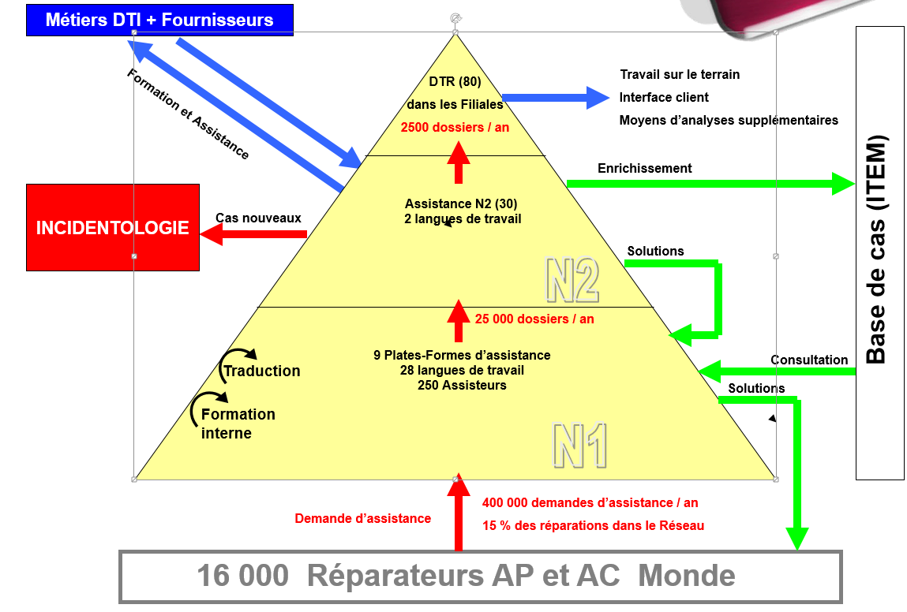

Process of raising an assistance request:

Garage person logs into PAMIR application (Front Office).

Using ‘Contact Aide’ hyperlink, an assistance request is created. Garage person fills all the required details about the assistance request such as vehicle detail, spare part/guarantee detail. Once the request is filled completely and submitted, a zip file is generated with all entered information. There is a batch job (BatchDiagsftp) that runs and stores this file into a database, which then reflects into PAMIR.

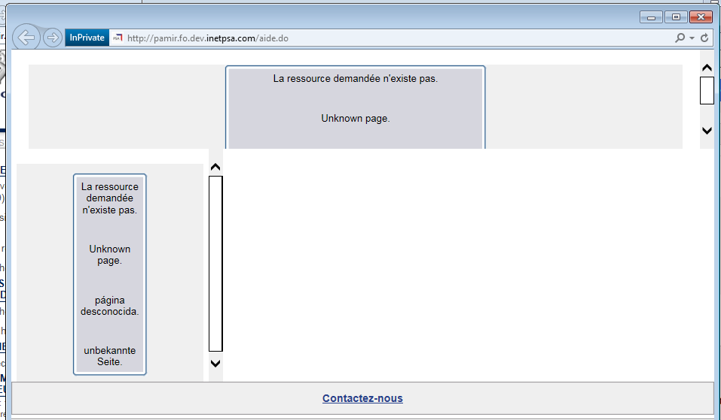

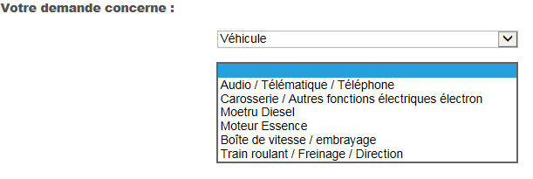

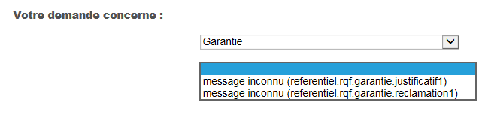

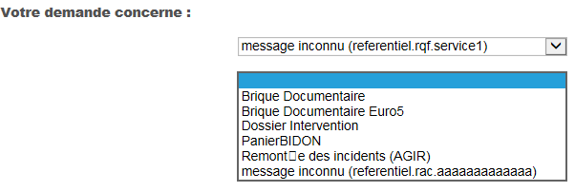

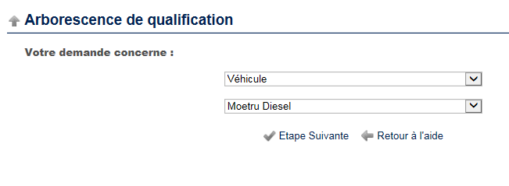

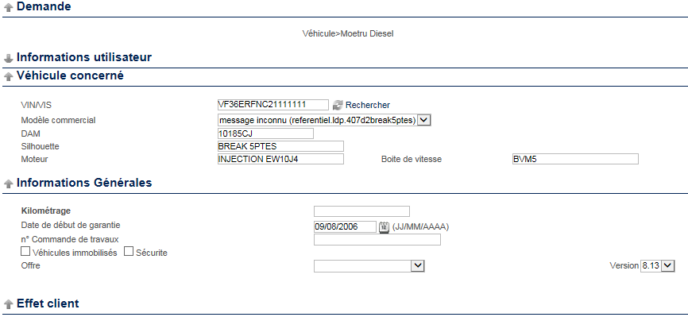

Garage person can also create a incident request (FAS/CRI) to report an accident/incident detail. In this, the garage person has to enter details about accident and the spare parts of vehicle.

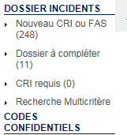

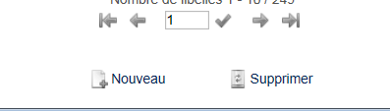

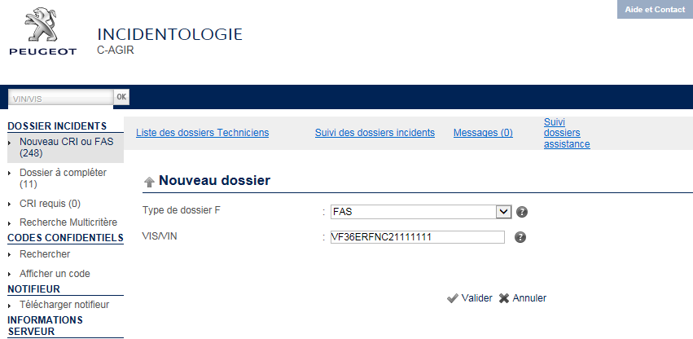

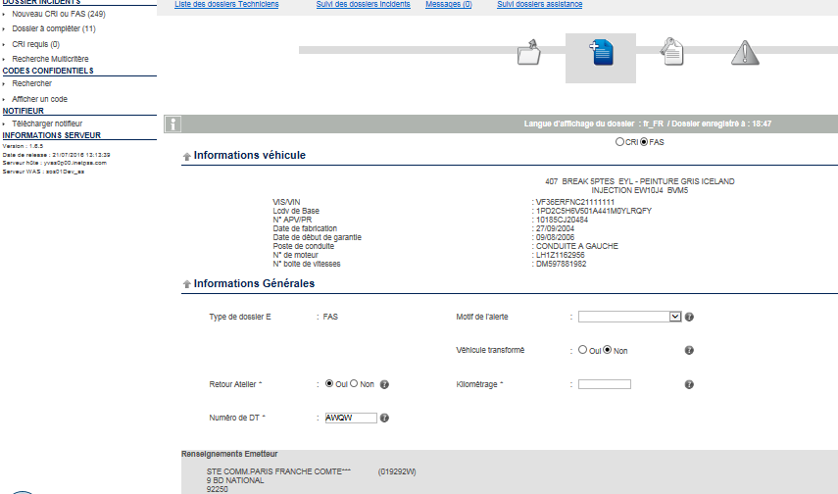

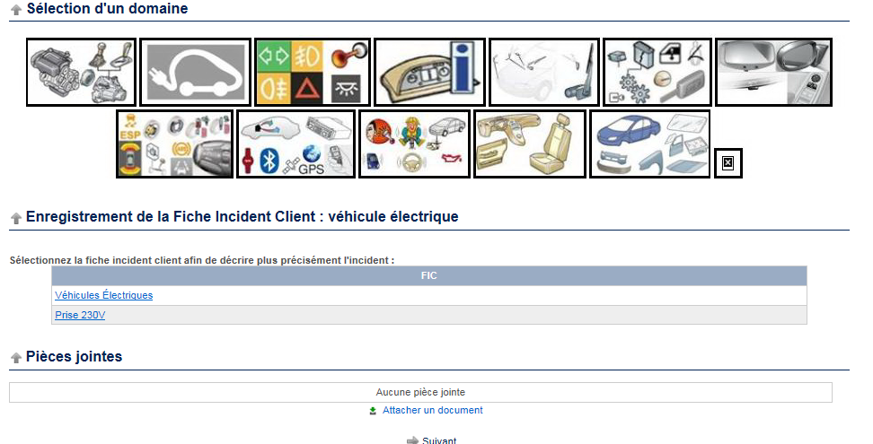

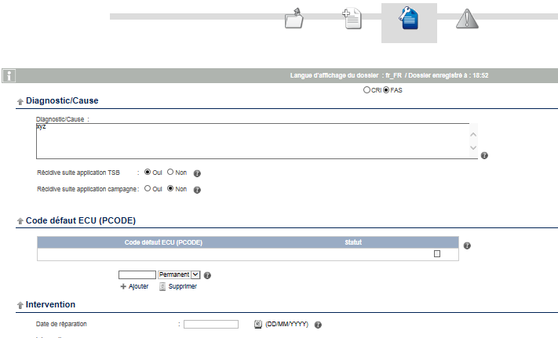

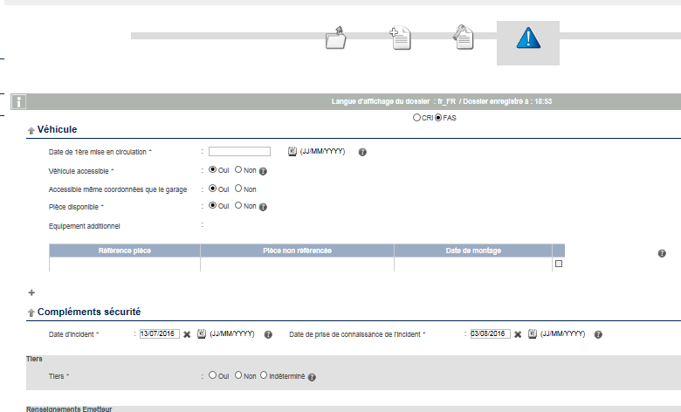

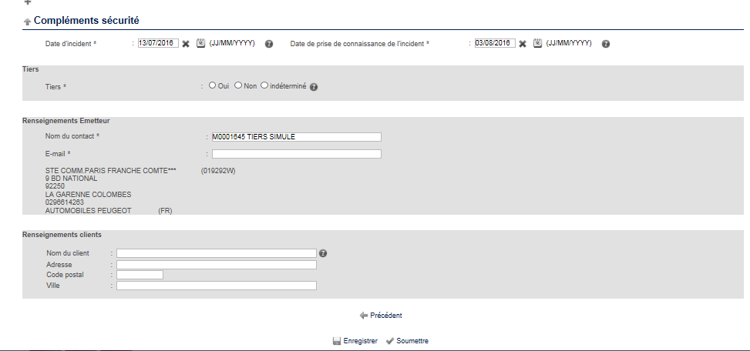

Once the batch runs and data is loaded into PAMIR back office, the assistance request is to be handled by a PSA technician.

PAMIR also gives a provision of obtaining electronic key (clef) through Fornt Office. Request is raised and then the key is obtained via email. This key is then by Garage person to unlock the vehicle

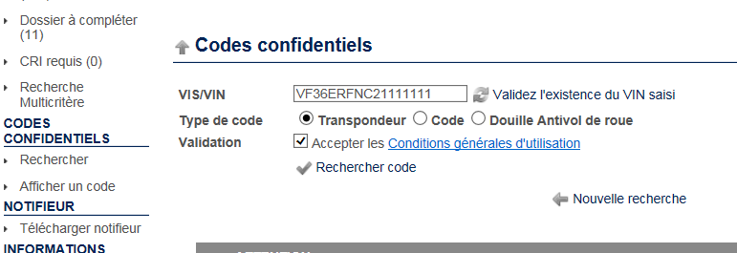

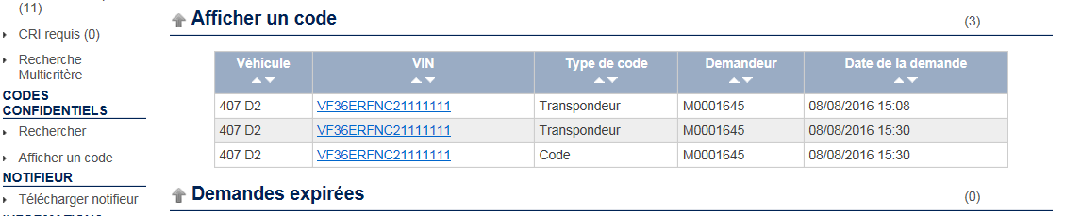

* 1. Data Flow

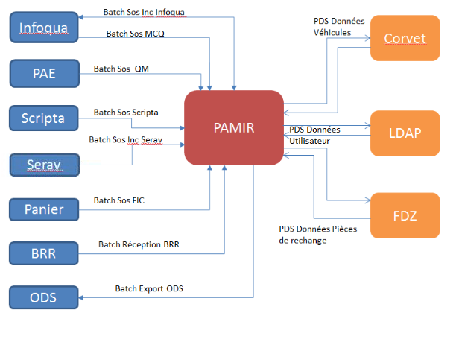

* 1. Summery of flow/Application Interface

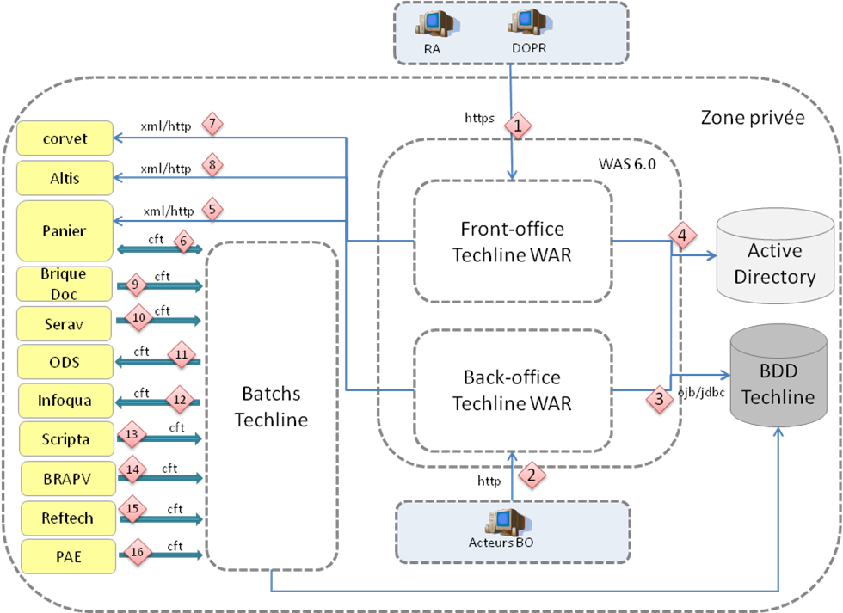

|  |  |  |  |  |
| --- | --- | --- | --- | --- |
| **N°** | **Source** | **Target** | **Mode Exchanges** | **Description** |
| 1 | browser | Techline FO | HTTPS | Access of the FO users to the Techline application.  Protocol HTTPS is managed by the infrastructure. |
| 2 | browser | Techline BO | HTTP | Access of actors BO to the Techline application |
| 3 | Techline | BDD Techline | JDBC | Access to the data of the base Techline  (DAT/CRI/FAS/RI…) |
| 4 | Techline | Activate Directory |  | Authentification of the users Access to the data  of the user |
| 5 | Techline | Basket | XML/HTTP | Catch of service for obtaining information on the  FIC |
| 6 | Techline | Basket | CFT | Batch of export of the engines of rules for  integration by the basket |
| 6 | Basket | Techline | CFT | Batch of importation of the relevance of the rules |
| 7 | Techline | Corvet | XML/HTTP | Catch of service for obtaining information of a vehicle. |
| 8 | Techline | Altis | XML/HTTPS | Catch of service for the Altis questions |
| 9 | Doc. scrubs | Techline | CFT | Batch of integration of the data allowing the  diffusion of Infoflashs/Inforapid. |
| 10 | Serav | Techline | CFT |  |
| 11 | Techline | ODS | CFT | Batch of food of ODS by the validated files and the  updated IH. |
| 12 | Techline | Infoqua | CFT | Batch of food of INFOQUA by the sending of the  Files in statute ‘Codified’. (to be confirmed) |
| 13 | Scripa | Techline | CFT | Batch of integration of the IF/IR |
| 14 | BRAPV | Techline | CFT | Batch of update of the hierarchy network,  information PDV, information contacts  (batchs BRR) |
| 15 | PAE | Techline | CFT | Batch of integration of the effects customers,  conditions of appearance and questionnaires trade |
| 16 | Techline | SAGAI | XML/HTTP | Catch of service for obtaining information on the  guarantee of a vehicle |
| 17 | SAGAI | Techline | CFT | Batch for the agreements on sensitive parts |
| 18 | SAGAI | Techline | CFT | Batch for the follow-ups of the DA (statutes) |

# **TECHNOLOGY RELATED**

* 1. Technical Overview
* Number of Screens
  + 100
* Number of Batch processes – 15
* Number of Reports
* Number of Interfaces (Input/Output)
* List of Languages implemented by UI screens (French, English, Spanish etc)
  + Level 1 (N1) support 28 languages
  + Level 2 (N2) supports 2 languages
* Language used for code variable nomenclature and Database – French and English
* Non-Functional Requirements:
  + Active users
  + Concurrent users
  + Concurrent transactions
  + Response time

External Applications - Car information is retrived from VIN (vehicle number) via a different application called CORVET via a web service call

Tec

* 1. Application Architecture

No document available

* 1. Application Platform

* 1. Source Code Control

<http://svn.informatique.inetpsa.com/svn/sos00/Etudes/trunk>

* 1. Production, UAT and Development Locations

Production :

BO PROD : https://pamir.mpsa.com

FO PROD  AC : https://pamir-networkservice.citroen.com

FO PROD  AP : https://pamir-servicebox.peugeot.com

Pre production :

BO PREPROD : https://pamir-preprod.mpsa.com

FO PREPROD AC : https://pamir-networkservicetest.citroen.com

FO PREPROD AP : <https://pamir-serviceboxtest.peugeot.com>

DEV environment links:

http://techfile.dev.inetpsa.com

http://pamir.fo.dev.inetpsa.com/index.jsp

* 1. Hardware and Software Pre-requisites

No specific point discussed about it.

* 1. Interfaces to other systems

PAMIR interfaces to many applications,

* CORVET – Fetch Vehicle information and other data based on VIN number
* Infoqua – This application provide essential files form working of PAMIR application

More information needed on this.

* 1. Documentation

Below Functional Document received from SME

French Systran Translated:

* 1. Network Specific Issues

No specific point discussed about it.

* 1. Third Party Tools

No third party tools discussed

# **Technical Environment**

* 1. Server Names
  2. Web Locations

<<>>

* 1. Web URLs

Production :

BO PROD : https://pamir.mpsa.com

FO PROD  AC : https://pamir-networkservice.citroen.com

FO PROD  AP : https://pamir-servicebox.peugeot.com

Pre production :

BO PREPROD : https://pamir-preprod.mpsa.com

FO PREPROD AC : https://pamir-networkservicetest.citroen.com

FO PREPROD AP : <https://pamir-serviceboxtest.peugeot.com>

DEV environment links:

http://techfile.dev.inetpsa.com

<http://pamir.fo.dev.inetpsa.com/index.jsp>

* 1. On-Line Region

No specific point discussed about it.

* 1. Libraries

Many libraries are used and imported as Maven Dependencies

* 1. Software Requirements

No specific point discussed about it.

* 1. Server/Application access requirements

Tomcat 5.5 for local and Websphere 6 for Development, Pre-Production and Production environment

* 1. Login IDs on Production and Development

No specific point discussed about it.

* 1. Test data and Test environment

No specific point discussed about it.

* 1. Change Control Procedure

No specific point discussed about it.

* 1. Forms

No specific point discussed about it.

* 1. Reports

No specific point discussed about it.

* 1. Tools

Eclipse 4.3.2 JavaXtd

Maven

Tomcat 5.5

Oracle 11g.

* 1. Methodologies

Waterfall model practiced. For the evolution/enhancement project, the pilot provide the timelines for development and delivery into pre-prod.

* 1. Complexity

No specific point discussed about it.

* 1. Unusual coding practice

JUnits are not written in PAMIR application.

* 1. Commonly used routines

No specific point discussed about it.

# **Datasets & Databases**

* 1. Overview

Database names and details mentioned in Environment Setup document.

* 1. Tables

No specific point discussed about it.

* 1. Stored Procedures

No specific point discussed about it.

* 1. User-Ids

User ID mentioned in attached Environment Setup document.

* 1. Performance Requirements

No specific point discussed about it.

# **Application Components**

* 1. Naming Standards

Standard naming conventions followed. No specific rule set in place.

* 1. Batch

Multi batch jobs run for PAMIR application. (Around 15) Each batch has a batch project in SVN. Major batch includes,

* DIAGSFTP – This is the batch job that runs in every 10 seconds interval in production. This facitlitate the file transfer from other application to front office and back office of PAMIR.

The directory for front office and back office is the same.

* INFOQUA – This batch runs daily (once in a day at 2am). This batch loads all the files from INFOQUA application which are required for PAMIR. If any required file is not found, an incident is raised.
* PFA for the batch details



* 1. Main Components

Major components of PAMIR application includes,

* FO Module – This contains sosfoEar, sosfoRoot, sosfoWeb, sosfoJava
* BO module – This contains sosboEar, sosboRoot, sosboWeb, sosboJava
* Common Module – sosJava
* Batch Projects

# **OPERATIONAL REQUIREMENTS**

* 1. Application Administration

The Pilot monitors and administers the PAMIR application.

* 1. DR Process & documentation

In case if a build fails in production, the previous build is deployed. No other disaster recovery plan in place. No document provided.

* 1. Daily, Weekly, Monthly, Quarterly, Monthly Checks/Activities

No checks to be performed by developer/collaborator. The Pilot/INDUS team facilitates these activities.

When any of the batch fails, there is a tool that monitors the application batches and raises an SDI incident for it.

The tool information was not mentioned by the SME.

.

* 1. On Demand/Request

No specific point discussed about it.

* 1. Backup Information

No specific backup plan in place. If a build fails, the previous version is restored.

# **PROCESS RELATED**

* 1. Change Control

For Evolutions/enhancements - The code release version for enhancements/evolutions are provided by Pilot

For defect fixes (changements) – The code fix is merged into the code stream which release date matches with the date provided by Pilot.

SVN is used for code management.

* <http://svn.informatique.inetpsa.com/svn/sos00/Etudes/trunk>

* 1. Problem Management
* The VCO operations are handled in below manner
* Incidents – In case of a severe impact issue like, server failure, application initialization failure, batch start problem, an Incident is raised on SDI and assigned to collaborator (developer) for analysis. If its batch problem, correct the same, and then ask INDUS to rerun the batch. The Incident for PAMIR is required to be resolved and services restored within 1 hr. All the stakeholders, INDUS, Pilot, Collaborator work jointly to resolve the incident.

|  |  |  |  |  |
| --- | --- | --- | --- | --- |
| **Page Title** | **Application** | **Problem summary** | **Solution** | **Related Artifacts** |
| File transfer issue(Batch incident) | PAMIR | A batch is run to transfer the file but failed because the file was not present in the specified folder(most of them are resolved). It is a repetitive incident | Ask for the file from the concerned competency cell (eg Infoqua or diagsftp) and place it under the proper folder structure using FileZilla | INCI06898111 |
| Server down | PAMIR | 1 out of 4 servers is down. It is in WAIT state | Could not find the solution to it. But it not because of Out of memory issue or web services. | INCI06829918 |
| File missing | PAMIR | File was missing I the specified folder so could not get transferred to its destination when the batch was run | Ask for the file from the concerned people and add it in the folder | INCI06802013 |
| Memory issue | PAMIR | Memory issue | Indus has to resolve this issue | INCI06880115 and INCI06860695 |
| Could not start the application – CHINA | PAMIR | Could not start the application due to internet connection or internal connection issue. Not our issue | Configure internal connection | INCI06845269 |
| Session process issue | PAMIR | Regarding the session process. Not related to PAMIR application. Related to some other application. | Transfer the incident to Pilot and he will assign it to the concerned department. | INCI06833638 |
| Server is not working | PAMIR | Out of 4 servers 1 is not working and so it is in WAIT state | Still in WAIT state | INCI06829893 and INCI06829918 |
| File missing from infoqua | PAMIR | File is missing in the specified directory so could not transfer it to the destination folder. | Get the file from Infoqua and add it to the specified folder. | INCI06778584 and INCI06784820 |
| Server issue | PAMIR | 1 server was not working. | Could not find the exact area of failure from the log file and so just found the machine name and restarted the server.  Anything related to server has to be solved by Indus and if he fails then it should come to us. | INCI06777339 and INCI06777267 |
| Database connection issue | PAMIR | Incident was logged in by the automatic Monitoring tool. The issue was regarding the database connection issue with the user. | Restart/Relaunch the database server. | INCI06731564 |
| PAMIR access failure through DEPILE application | PAMIR | User was not able to access PAMIR through DEPILE application. DEPILE has 2 folders – 1 for NEWAGIR and other for PAMIR | Transferred it to the DEPILE team | INCI06717101 |
| User could not access PAMIR application | PAMIR | User could not access PAMIR application due to incorrect internal configuration | Correct the internal configuration | INCI06667483 |
| Could not upload file | PAMIR | User could not upload the file because flash builder was not present in the browser. | Add Adobe flash builder plugin in the application | INCI06656324 |
| Could not send file | PAMIR | Pamir could not send file because the session was not running & was in pause mode | All the sessions and services were restarted automatically. Indus is responsible for starting or stopping the session or service. | INCI06669358 |
| Could not view the PDF file in IE 11 but was visible in IE 9 | PAMIR | PDF file was not getting correctly displayed in IE11 however it works fine in IE9 | Some MSIE certificate was missing in IE11 and was present in IE9. MSDN (Microsoft developer network) was used to get the MSIE certificate for IE11 | INCI06656549 |

* + Anomaly – For bugs in application which are not critical as incidents, an anomaly is raised in JIRA and assigned to collaborator (developer). The collaborator identifies the code fix for the issue, creates a changement and delivers the code in development and tests the same. If successful the build is tested in pre-prod by the Pilot, and on confirmation by Pilot the build is delivered to Production.
  + Assistance – An assistance request is created on JIRA is any help is needed from the developer.

* 1. Release Management

No specific release notes maintained. Pilot decides the release date as well as the code version naming for the particular changement release.

* 1. Size/Complexity/Criticality

No specific point discussed about it.

* 1. Coding Standards

Only PSA checkstyle followed. Existing code has many violations

* 1. Metrics
* Code coverage – Not Applicable as Junit test classes are not written for PAMIR application.

# **CONTACT INFORMATION**

* 1. Business Contacts

(Functional SME) PFA : Pascal CHARTON

(Pilot) CPI : Jérôme GOLIAS

* 1. Support Team Contacts

No specific point discussed about it.

* 1. Third Parties Contact Information

No specific point discussed about it.

* 1. Client Support

No specific point discussed about it.

* 1. Infrastructure (Server/Network)

No specific point discussed about it.

* 1. DBAs

No specific point discussed about it.

* 1. Other contact

No specific point discussed about it.

# **PROBLEM REPORTING**

* 1. Helpdesk details

No specific point discussed about it

* 1. Vendor Details

No specific point discussed about it.

# **APPLICATION HISTORY**

* 1. Typical Problems

Typical Problem includes,

* Display issues of attachments
* Insufficient space: attachments
* Batch in error: File (exceeded time)

* 1. Tips & Tricks

No specific point discussed about it.

* 1. Application Release History

Current version in PROD: 1.5.23

Current version in Dev: 1.6.2

|  |  |  |  |  |  |
| --- | --- | --- | --- | --- | --- |
| Date | Version | Full/Upgrade | Released to Locations | Description | Release Made By |
|  |  |  |  |  |  |

# **GLOSSARY**

|  |  |
| --- | --- |
| **Wording** | **Definition** |
| DA (T) | Files of Assistance (Technical) |
| Techline | Application of technical assistance of the group |
| ODS | Application of Diagnostic tools |
| BRR | Base reference frame Network |
| RU | Return User |
| DOPR | Distributer Spare part |
| CRY | Report of Intervention |
| FAS | Card-index Alarm Security |
| IH | Incident report |
| PR | Spare part, a new under-field of the assistance in the Techline application |
| APV | After sales |
| BO | Back Office |
| FO | Face Office |
| RA | Approved repairer |
| CS/SB | Citroën Service/Service Box: two hubs giving access to the functions of incidentology and follow-up of the files of assistance. |
| CCT | Control tower |
| FIC | Card-index of Incidental Customer |
| The FIT | Card-index of Incidental Technician |
| ALTIS | Third system used by the control towers. |
| CTP | Technical coordinator Country |
| DTR | Regional Technical direction |
| FNR | Internal supplier |
| GAR | Guarantee |
| PDS | Catch of Service |
| HUB | The HUB CS/SB in which is carried out FO Techline (cf classifies HubTools). |
| PDV | Retail outlet |
| QM | Questionnaire Trade (in the case of a FAS and according to the type of incident) |
| POI | Gate of the Independent Operators |

# **REFERENCE DOCUMENTS**

 

* 1. Templates
  2. DLEI sample document was shared. To be shared

**SVN**

<http://svn.informatique.inetpsa.com/svn/sos00/Etudes/trunk>

Production, UAT and Development Locations

BO PROD : <https://pamir.mpsa.com>

FO PROD  AC : <https://pamir-networkservice.citroen.com>

FO PROD  AP : <https://pamir-servicebox.peugeot.com>

Pre production :

BO PREPROD : <https://pamir-preprod.mpsa.com>

FO PREPROD AC : <https://pamir-networkservicetest.citroen.com>

FO PREPROD AP : <https://pamir-serviceboxtest.peugeot.com>

DEV environment links:

<http://techfile.dev.inetpsa.com>

<http://pamir.fo.dev.inetpsa.com/index.jsp>

Web URLs

Production :

BO PROD : <https://pamir.mpsa.com>

FO PROD  AC : <https://pamir-networkservice.citroen.com>

FO PROD  AP : <https://pamir-servicebox.peugeot.com>

Pre production :

BO PREPROD : <https://pamir-preprod.mpsa.com>

FO PREPROD AC : <https://pamir-networkservicetest.citroen.com>

FO PREPROD AP : <https://pamir-serviceboxtest.peugeot.com>

DEV environment links:

<http://techfile.dev.inetpsa.com>

<http://pamir.fo.dev.inetpsa.com/index.jsp>

**DATABASE** :

URL = *" jdbc: oracle: thin: @yvas0p00.inetpsa.com: 1521: S.O.S”*

*host:* 10.80.80.165 yvasa090.inetpsa.com